# Tutorial

## Activity 1: Writing copy for your first web page

In the lab this week, you will be forking and cloning a starting repo which contains very basic HTML5 web page templates, one which you will modify with some information about yourself.

Some things to think about:

* How do you use the internet?

For researching materials, communication (video call, chatting) and entertainment (YouTube, music, movies, online game etc)

* What websites do you visit? (NB: "family friendly" !)

YouTube, Google, Facebook

* Have you any programming or web design experience?

Yes, I have a little experience with HTML from my ICT class in highschool and I had an opportunity to work with website from my Intro to IT class. Overall, I'm still new to coding and there are still many aspects of web designing that I still need to learn.

* Do you see yourself as a programmer or designer, or both?

Personally, I think that I'm more of a programmer.

* What has brought you to this course at RMIT?

Nowadays, websites are ubiquitous due to their quick accessibility and ease to use. They have become an indespensible part of our daily lives and can be used for many different purposes and scenarios. With that said, I think that being able to build a website would be a very useful skill that would support me in the future

* What are you hoping to get out of the course?

I hope I can acquire more knowledge regarding HTML and using CSS to customize my website. I also hope that I will be able build a functional website with PHP and JavaScript as this would help me with my future projects.

* What are your interests or hobbies?

I usually spend my free time reading books, drawing or playing games.

Work with one or two friends to flesh out your copy.

This activity is to get to know your classmates and yourself a little better. By the end of this exercise you should have some idea of what to put in your personal webpage.

For administrative reasons, there will be a few other fields to fill in (name, student number, a personal photo). This will help the entire web programming team get to know you better and more importantly know how to pitch answers to your questions.

## 

## 

## Activity 2: Examine the Elements of a Webpage

Have a look at the following webpage: <http://www.w3schools.com/html/html_intro.asp>. The top and bottom of the page is shown with a red bar separating the two sections. *If you have a laptop please have a look at the live version*.

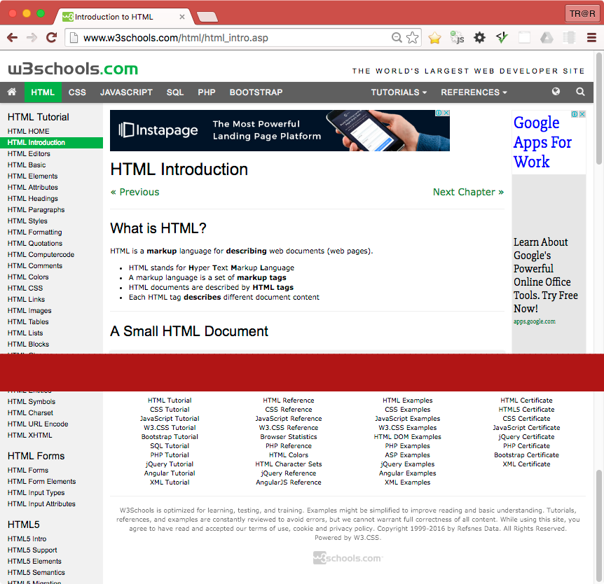

* On the webpage above, identify the following web elements:
  + Headings (eg <h1>...</h1>, <h2>...</h2>, … , <h6>...</h6>),
  + Paragraphs (<p></p>),
  + Anchors or Hyperlinks (<a href="...">...</a>),
  + Images (<img src="..." alt="..."/>) and other multimedia.
* Identify styling such as **bold** and **italic** text. We will cover shading and colouring next week.
* What is the difference between an **unordered list** (<ul>) and **list items** (<li>). Can you see examples of each on the webpage above?
* <ul> is the parent tag of <li>
* Does this website use modern HTML5 Contextual Elements? (eg <header>, <nav>, <main>, <footer>, <aside>). Identify which areas should be grouped into these elements.

Navigation bar with <nav>

The part above nav bar - <header>

Copyrights - <footer>

Advertisements - <aside>

Main article - <main>

* How many navigation elements are there? If more than one, why are there more than one?

2. One for the navigation bar on top and one for the navigation bar on the left.

## 

## 

## 

## Activity 3: Evolution of the HTML standard

What page elements were present in the very first versions of HTML? What form did the first web documents take?

HTML3 and HTML4 standards were developed at a time that was seen as being very chaotic. Name some reasons for why this was and state what new elements we saw introduced at this time.

The XHTML standard is described as being very strict, quite unlike HTML3 and 4. What rules did XHTML impose on developers? Think in terms of:

* Tags: closing and nesting them in correct sequence.
* Use of uppercase and lowercase characters.
* Separation of style and content

How did these changes allow XHTML documents to be more accessible across a wider range of devices: eg PC's, early WAP enabled mobile phones, screen readers for the visually impaired etc.

HTML5 introduced many new elements and attributes. Think in terms of:

* Simpler doctype declaration.
* New tags, including standard multimedia tags (audio/visual).
* New form inputs, validation of form data using html markup, not code/scripting
* Semantic Web elements

Discuss the benefits and improvements contained in the HTML5 standard.

Finally, HTML5 has brought back many (but not all) of HTML4's more relaxed coding rules. What are they and why are the strict XML syntax rules of XHTML no longer needed today?

## 

## 